CS 305 Module Five Coding Assignment
Certificate Generation
Lawrence Langelier Jr
A certificate authority (CA) is a trusted third party that verifies the identity of a website or organization and issues digital certificates. When users connect to a website using HTTPS, their browser checks the certificate provided by the server. If the certificate was issued and signed by a trusted certificate authority, the browser knows that the website is legitimate and that the connection can be trusted.
Using a certificate authority improves security because it helps confirm that users are communicating with the real website and not a fake one created by an attacker. This helps prevent attacks such as phishing or man-in-the-middle attacks where someone tries to intercept communication between a user and a server.
One advantage of using a certificate authority is trust. Browsers and operating systems already trust certificates issued by well-known CAs, so users can safely connect to websites without needing to manually verify them. Another advantage is secure encrypted communication using HTTPS, which protects sensitive information like passwords, financial information, and personal data while it is being transmitted over the internet.
During development, developers often generate self-signed certificates instead of purchasing certificates from a certificate authority. A self-signed certificate allows developers to test secure communication without needing to register a domain or pay for a certificate. In this assignment, I generated a self-signed certificate using the Java Keytool utility, which simulates how certificate authorities provide authentication for secure connections.
Screenshot 1 – Certificate information entered during key generation
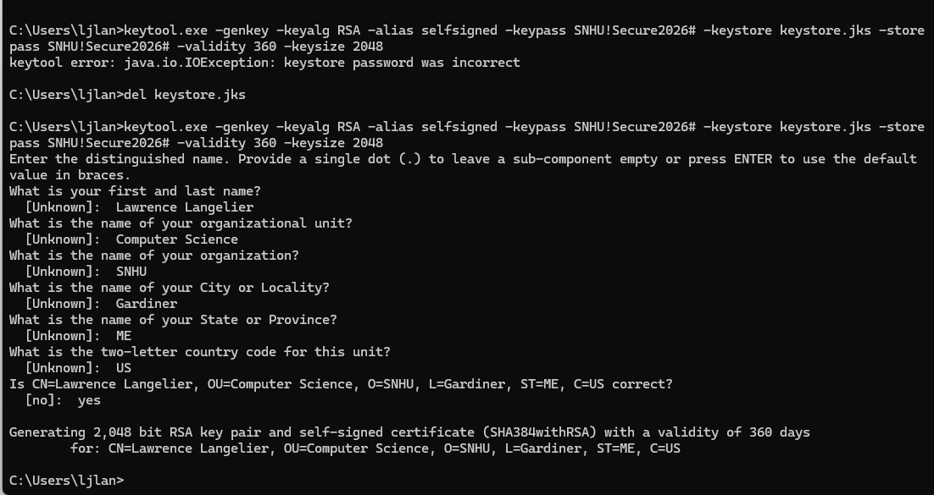

Screenshot 2 – Certificate exported successfully
Screenshot 3 – Printed certificate details from server.cer
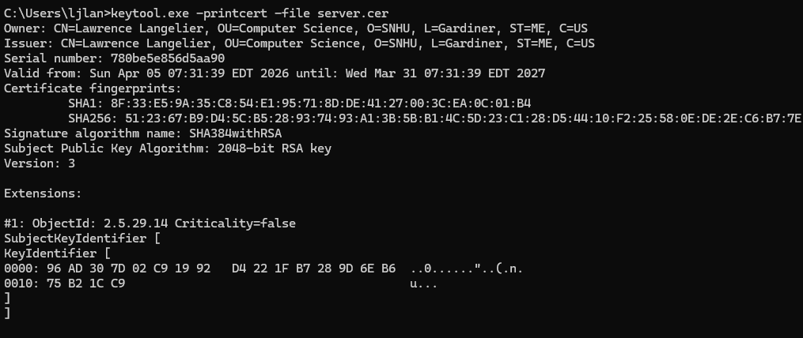

References
Oracle. (n.d.). Keytool: Key and certificate management tool. https://docs.oracle.com/en/java/javase/17/docs/specs/man/keytool.html

